The Antikythera Mechanism at LA28: Bridging Millennia of Innovation

By Xenophon Moussas, University of Athens, Dep. of Astrophysics, Astronomy and Mechanics, e-mail: xmoussas@phys.uoa.gr, e-mail: xdmoussas@gmail.com, tel +30 6978792891

Featuring a replica of the Antikythera Mechanism as part of the LA28 Olympic Games opening ceremony would serve as a powerful visual and symbolic bridge: connecting the Games’ ancient Greek origins with Los Angeles’ pioneering spirit in storytelling, science, culture, and high technology. Just as the Olympic flame symbolizes passion and endurance across generations, the Mechanism would embody the timeless human quest to measure the heavens, understand our world, and align human life with cosmic order.
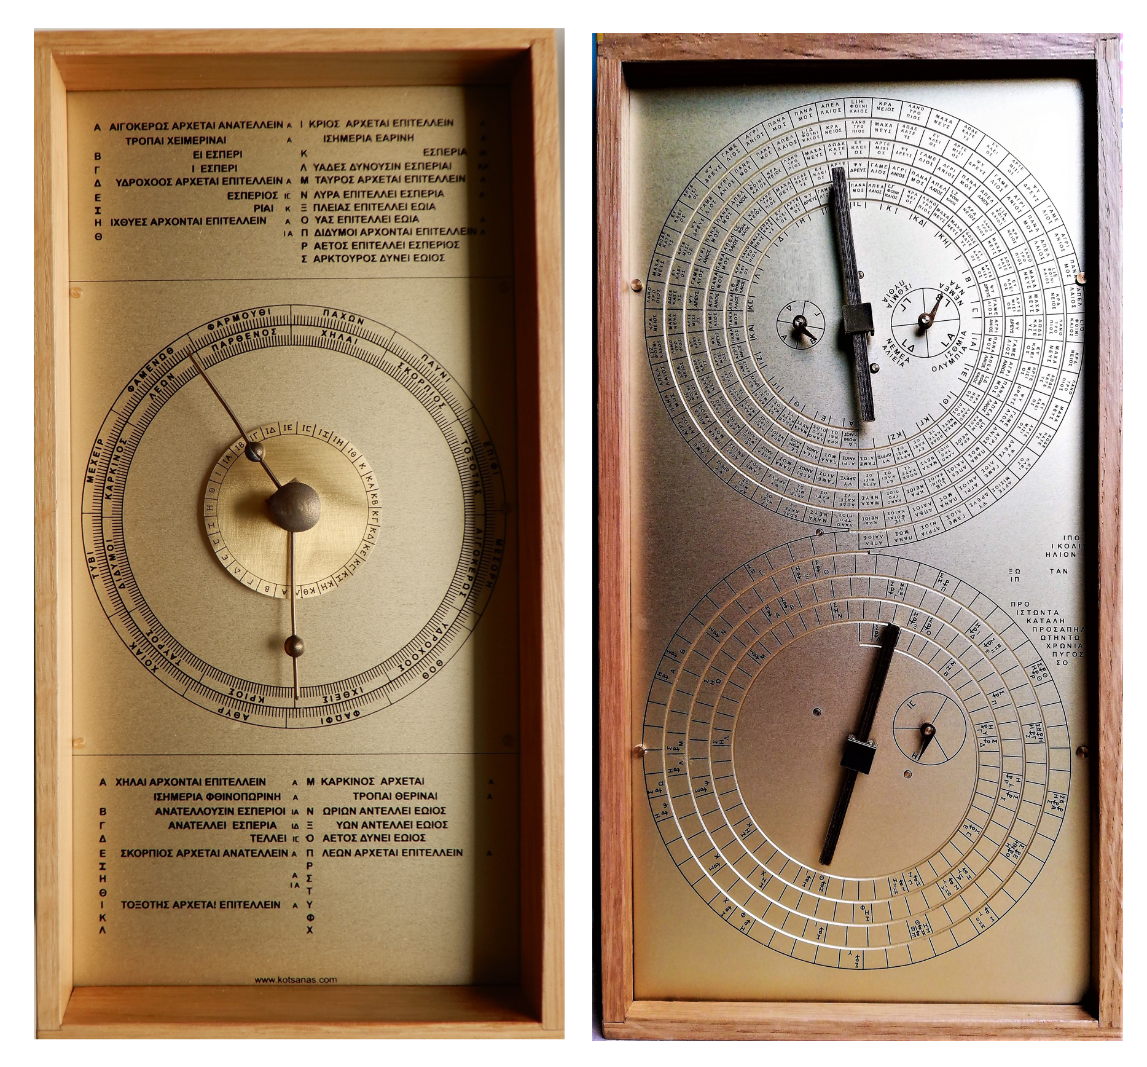
Figure 1 the Mechanism is like a double-faced clock, one-foot height. This is a model made based on our research

What is the Antikythera Mechanism?
The Antikythera Mechanism is the world’s oldest known analog computer, built in ancient Greece around 150–100 BCE.
It is a complex system of bronze gears housed in a wooden case, discovered in 1901 in a shipwreck near the island of Antikythera.
Its functions included:
- Predicting eclipses of the Sun and Moon.
- Tracking the cycles of the Moon and planets.
- Showing the Metonic cycle (19 years) and the Saros cycle (18 years, 11 days).
- Determining the dates of the Olympic Games and other Panhellenic festivals.
In short: it’s a mechanical cosmos in a box—a miniature universe demonstrating how the Greeks unified astronomy, mathematics, and philosophy into technology.
- Built in ancient Greece around 150–100 BCE.
- It is a complex mechanism a computer programmed with carefully designed bronze gears housed in a case, discovered in 1901 in a shipwreck near the island of Antikythera.
- Its functions based on Pythagorean philosophy included:
- Predicting eclipses of the Sun and Moon.
- Tracking the cycles of the Moon and planets.
- It is a calendrical machine too. Is has several ancient Greek calendars that it synchronizes. An Epirotic calendar is based on the Metonic cycle (19 years) which is the calendar we use for Easter, Passover and other festivities.
- It predicts the eclipses based on the Saros periodicity (223 months or18 years, 11 days) and Exeligmos cycle 669 months.
- Determining the dates of the Olympic Games and other Panhellenic festivals, based on an eight-year cosmic dance of the Sun the Earth, Venusand the Moon.
In short: it’s a mechanical cosmos in a box—a miniature universe demonstrating how the Greeks unified astronomy, mathematics, and philosophy into technology
Discovered in a shipwreck off the coast of Greece, this extraordinary device (c. 2nd century BCE) is the world’s first known analog computer. Through a system of bronze gears, it calculated celestial cycles, predicted eclipses, and most significantly, determined the dates of the ancient Olympic and Panhellenic Games. The Mechanism thus unites science, philosophy, and cultural tradition: proof that the pursuit of knowledge was at the heart of the Olympic spirit.
Pythagoras taught that the cosmos is harmony — a music of the spheres. The Antikythera Mechanism makes this harmony visible, its gears turning like celestial strings, marking the cycles of the Sun, Moon, and planets. It is a Pythagorean machine, where philosophy, mathematics, and technology unite to reveal the hidden music of time.
Plato taught that our lives, cities, and creations must reflect the harmony of the cosmos.
The Antikythera Mechanism embodies this principle: a marvel of gears and ratios that translates celestial order into human understanding—an ancient fusion of philosophy, science, and art.

The Harmony of the Cosmos: Pythagoras, Plato, and the Antikythera Mechanism
For the Pythagoreans, the cosmos is harmonious and resonates with cosmic music. The ordered harmony woven from the mathematical ratios of numbers and vibrating strings. They taught that the same proportions that shape the musical scale also govern the motions of the heavens. Each planet, each cycle, each celestial rhythm participates in the symphony of the spheres, inaudible to the ear yet inscribed in the structure of the universe.
The Antikythera Mechanism is a physical manifestation of this philosophy. Its gears embody the very same numerical ratios that define musical consonance. Just as a lyre string resonates at precise intervals, the gears resonate with cosmic time, translating the harmony of celestial cycles into motion. The device aligns the human calendar with the order of the heavens, showing that astronomy, mathematics, and music are not separate arts, but a single unified science of harmony.
Among the cycles encoded in the Mechanism are:
- The Octaeteris (8 years) — a resonance of the Sun, Earth, Moon, and Venus, equal to five synodic periods of Venus and 99 lunar months, a perfect cosmic “octave.”
- The Metonic Cycle (19 years) — harmonizing solar years with lunar months, still used today in the calculation of Easter and Passover.
- The Saros Cycle (223 lunar months, ~18 years, 11 days) — predicting eclipses, extended in the Mechanism to the Exeligmos (669 months) for greater precision.
- Longer harmonic cycles of 462 and 442 years — showing not only the recurrence of eclipses but the deeper periodicity of celestial resonances, akin to the grand bass tones of the cosmic scale.
Plato deepened this vision in the Timaeus. He described the creation of the cosmos as a divine dance of the heavenly bodies, each orbit a rhythm, each cycle a step in the eternal choreography. He urged that our festivals, cities, and even our souls must reflect this order — that human life is healthiest when it moves in step with the cosmic dances of Sun, Moon, and planets. The Olympic Games themselves were timed by these rhythms, a celebration of athletic and spiritual harmony aligned with the turning heavens.
The Antikythera Mechanism is not only a computer or a calendar, but a Pythagorean and Platonic instrument of cosmic harmony that reflects to humans. Its turning gears echo the “music of the spheres,” reminding us that the same laws that shape melody and harmony also govern the heavens. By synchronizing human life with planetary motion, it embodies Plato’s teaching that our lives, our cities, and our greatest festivals must reflect the harmony of the cosmos.
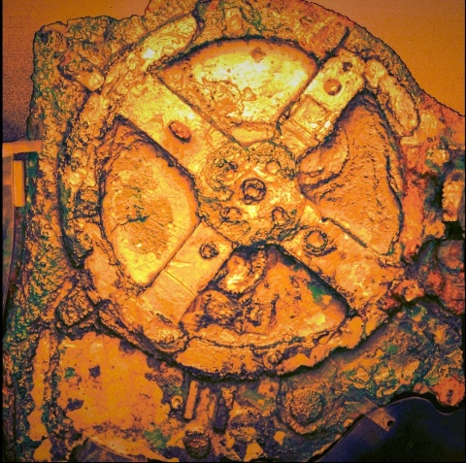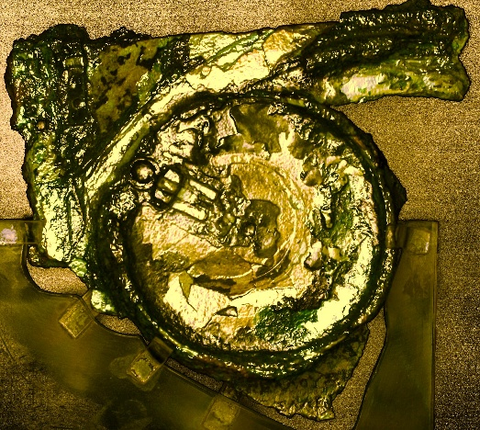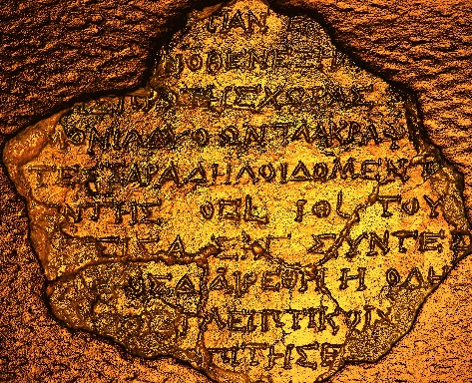
Figure 2 Images of the gragments of the originalMechanism at the National Hellenic Museum, Athens, Greece

The Ceremony Vision
Imagine an athlete or youth leader stepping forward at the start of the ceremony, holding the Mechanism aloft. This gesture—echoing the Olympic torch relay—would complement the flame.
- The torch symbolizes purity, enlightenment, passion, unity, and endurance, while
- The Mechanism would symbolize knowledge, innovation, and human creativity across 2,500 years.

Cicero’s Inspiration
As Cicero wrote of Archimedes’ mechanical planetarium, when ancient engineers reproduced the heavens in a sphere, they mirrored the divine craftsmanship described by Plato. Cicero believed such genius could inspire Roman youth to greater achievement. Likewise, showcasing the Antikythera Mechanism at LA28 would inspire today’s young people: reminding them that if the Greeks could build such a device two millennia ago, they too can innovate beyond the limits of their age.

Why Los Angeles?
Los Angeles is uniquely suited to tell this story:
Storytelling & Culture: Hollywood, Disneyland, and creative industries make LA the global capital of imagination.
Science & High Tech: Home to NASA JPL, SpaceX, Caltech, UCLA, USC, and Silicon Beach startups, LA is a hub of aerospace, biotech, and AI.
Philosophy & Ideas: A crossroads of East and West, where ancient wisdom meets modern innovation.
Diversity & Legacy: A city of cultures, stories, and traditions, just like the Olympic Games themselves.
In 2023, Hollywood placed the Mechanism at the center of Indiana Jones and the Dial of Destiny. Millions worldwide discovered this mysterious device through cinema. By including it in LA28, Los Angeles can complete the circle—uniting fact, myth, and imagination in a single, unforgettable Olympic moment.
The Mechanism inspires, the Mechanism teaches, the Mechanism connects — uniting ancient Greece and Los Angeles in a timeless quest for knowledge, harmony, and human greatness.
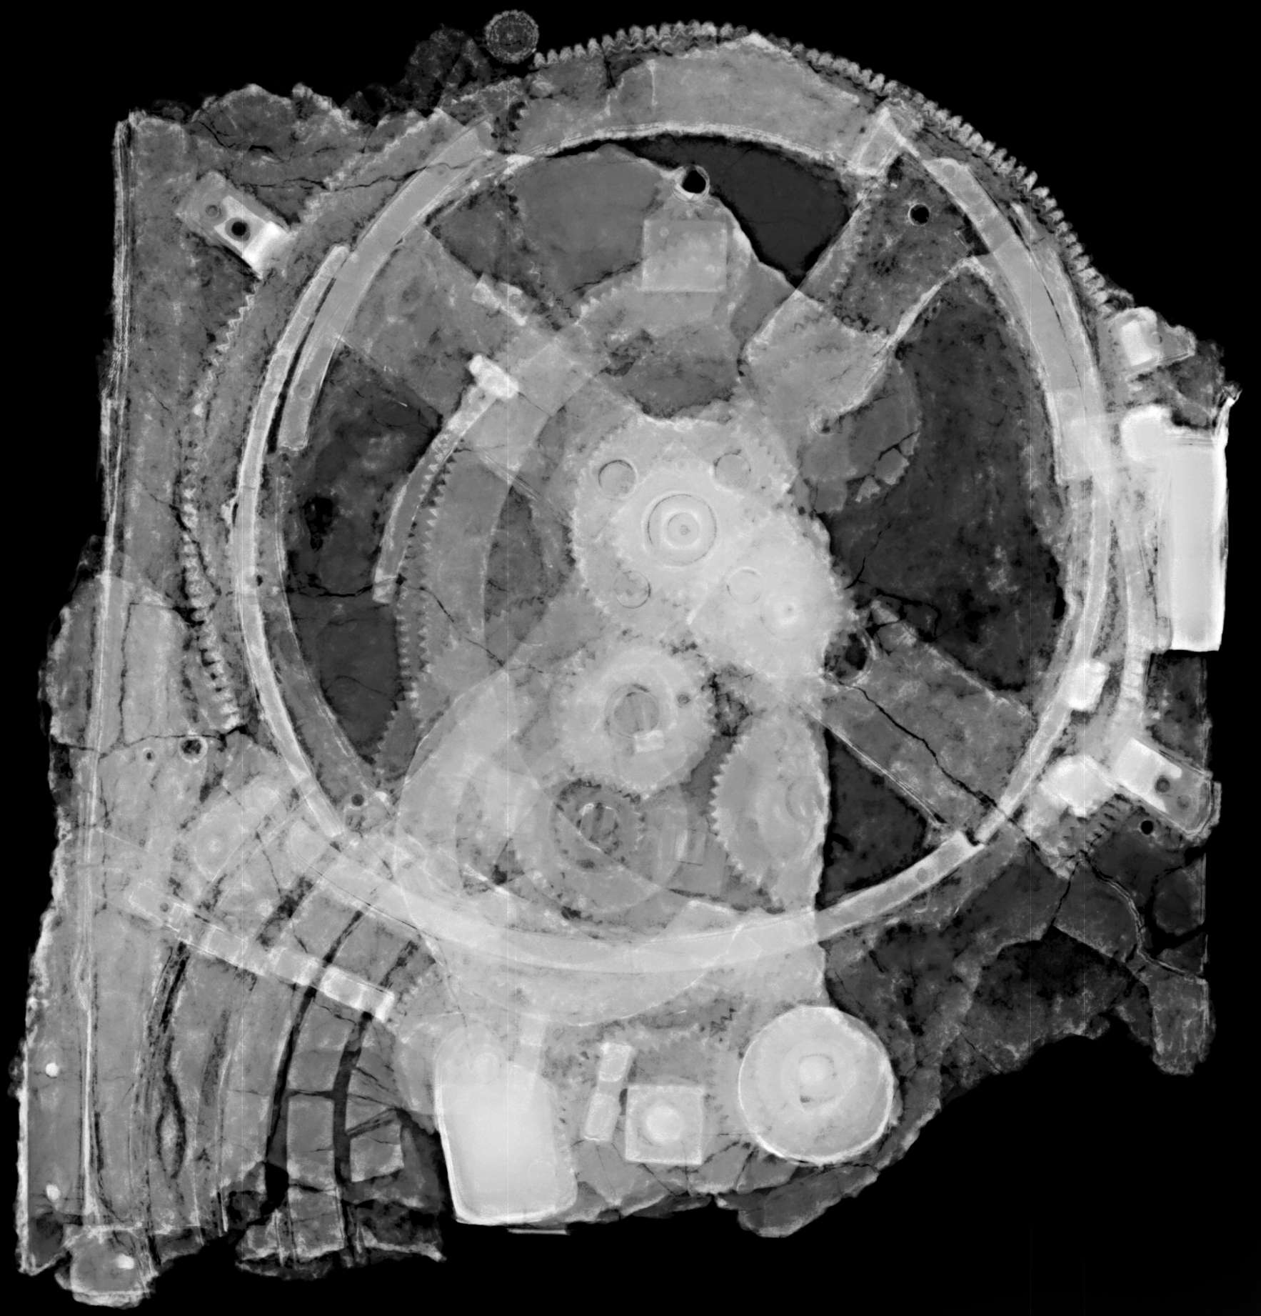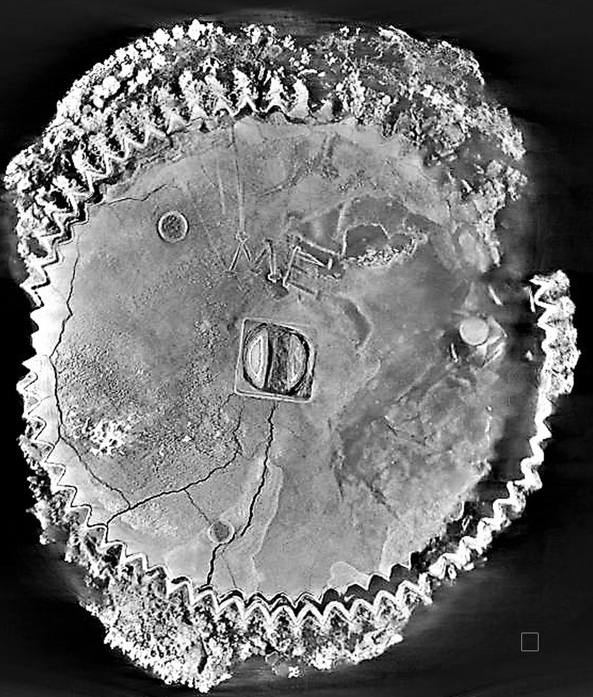
Figure 3 A radiography of the largest fragment and a CT of a small gear.

Symbolism and Impact
Cultural Prestige: Positions LA as both entertainment capital and curator of world heritage.
Education & Inspiration: Sparks youth interest in STEM, arts, and philosophy.
Global Recognition: Creates a narrative of innovation that resonates across time and cultures.
Tourism & Legacy: Encourages cultural tourism, museum partnerships, and long-term educational programs.
Identity: Complements the flame—flame = passion; mechanism = knowledge—a lasting image of LA as a city that connects past, present, and future.

Pythagoras, America, and High Tech
All high tech is based on Pythagorean principles, i.e. laws of nature expressed with mathematics.
Pythagorean and Platonic Harmony: The Mechanism reflects the Greek belief that the cosmos is governed by number, harmony, symmetry, simplicity and order.
American Philosophy: Like the Mechanism, American thought unites reason, freedom, and imagination—innovation tied to human progress.
High Tech LA: The Mechanism, the first computer, anticipates today’s Los Angeles—leader in space exploration, AI, biotech, and cinematic technology.

Conclusion
Featuring the Antikythera Mechanism at the LA28 opening ceremony unites three powerful traditions: the Pythagorean vision of a cosmos ordered by mathematics, the American spirit of innovation and progress, and the high-tech creativity of Los Angeles. This symbolic gesture will inspire a new generation by showing that the search for knowledge and harmony is timeless—from ancient Greece to modern America.
The Mechanism Inspires.
The Mechanism Teaches.
The Mechanism Connects

Curriculum Vitae – Xenophon D. Moussas
Professor (ret.) of Space Physics, University of Athens
Distinguished Greek Astronomer and Researcher of the Antikythera Mechanism

Education BSc in Physics, University of Athens (1971), PhD in Nuclear Physics (Cosmic Rays and Space Exploration), University of Athens (1977) xmoussas@phys.uoa.gr, e-mail: xdmoussas@gmail.com, tel +30 6978792891

Academic Career
- Professor of Space Physics, National and Kapodistrian University of Athens (NKUA), founder of the discipline of Space Physics at NKUA.
- Senior Visiting Research Fellow, Imperial College London (20 years, 3 months annually).
- Visiting Professor and Researcher at:
  - Imperial College London
  - National Autonomus University of Mexico
  - Paris Observatory
  - Max Planck Institute, Germany
Supervised dozens of PhD amd MSc theses, and 250 BSc theses in Greece and internationally.

Research & Scientific Contributions
- Renowned for major contributions to the study of the Antikythera Mechanism, the world’s oldest known computer.
- Extensive research in space physics, cosmic rays, and space exploration with active participation in numerous NASA and ESA space missions.
- With M. Tsikritsis, identified the Minoan stepped cylindrical tower at Papoura, Crete (2000 BC) as an astronomical observatory and agricultural calendar, naming it the “Minoan Gate to Heaven” — one of the earliest known examples of astronomical knowledge in Greece and worldwide.

Publications Books: 2 on Space Physics, 4 on the Antikythera Mechanism (several versions in Greek, one published in Russian; forthcoming editions in English, Spanish, French, Bulgarian, Albanian, Italian). Articles: Over 120 scientific papers in peer-reviewed journals, widely cited internationally.

Awards & Honors include:
- American Geophysical Union (2001) – Special recognition for peer review excellence.
- NASA Group Achievement Award (2009) – For contributions to the Ulysses NASA mission.
- Honorary Doctorate (2017) – International Pontic Academy of Education and Science, Ukraine.

Public Engagement & Exhibitions: Delivered ~2,000 lectures at universities, schools, and conferences worldwide.
- Organized and contributed to ~100 exhibitions on the Antikythera Mechanism and ancient Greek science and Philosophy in 14 languages across dozens of countries.
- Major exhibitions include:
  - NASA Kennedy Soace Center, Cape Canaveral)
  - UNESCO Headquarters (Paris)
  - Children’s Museum of Manhattan
  - Gustavianum Museum, Uppsala (Sweden)
  - National Autonomous University of Mexico, Universum
  - University of Sonora, Hermosillio, Mexico
  - Library of Alexandria (Egypt)
  - Drexel University (USA)
  - Cairo
  - Academy of Science Slovacia
  - Olsztyn Planetarium and Observatory (Copernicus Observatory, Poland)
  - Astronomical Institute of the Slovak Academy of Sciences
  - Évora, Portugal (ancient Roman site of Ebora/Emporion)
  - Venice (Istituto Veneto di Scienze, Lettere ed Arti)
  - Munich (Germany)
  - Algeria
  - Numerous Greek archaeological museums, universities, schools, cultural foundations, and astronomical societies, including the Ionian Center and the Eugenides Foundation (Athens).

Legacy & Impact Internationally recognized as a leading scholar bridging ancient Greek science, philosophy, and astronomy with modern space physics and cosmology. Contributions to the study of ancient astronomical devices (Antikythera Mechanism, Minoan astronomical architecture, and early Greek science) highlight the continuity of scientific thought from antiquity to the present.

Appendix

The Antikythera Mechanism: Bridging Time, Cosmos, and Human Aspiration
The Antikythera Mechanism, constructed in ancient Greece around 150–100 BCE, stands as the world’s oldest known analog computer — a mechanical cosmos in a box. Discovered in 1901 in a shipwreck near the island of Antikythera, it is an extraordinary testament to human ingenuity. This complex device, composed of carefully designed bronze gears housed in a wooden case, calculated the motions of the Sun, Moon, and planets, predicted eclipses, synchronized several ancient Greek calendars, and determined the dates of the Olympic Games and other Panhellenic festivals. In doing so, it translated the vast rhythms of the heavens into a tangible, comprehensible system — an intersection of science, mathematics, and culture that demonstrates how deeply the ancients understood the harmony of the cosmos.
Rooted in Pythagorean philosophy, the Mechanism embodies the principle that the universe is structured by numbers, proportions, and harmony. Pythagoras taught that the motions of the celestial bodies form a “music of the spheres,” a cosmic rhythm that underlies the order of all things. The Antikythera Mechanism makes this harmony visible: its intricate gears move like celestial strings, faithfully tracking the cycles of the Sun, Moon, and known planets. In essence, it is a Pythagorean machine, where mathematics, astronomy, and philosophy converge, offering an extraordinary physical manifestation of cosmic order and universal rhythm.
Plato further emphasized that our lives, our cities, and our creations must reflect the harmony of the cosmos, structured by beauty, proportion, and reason. The Antikythera Mechanism exemplifies this ideal, uniting technical precision with philosophical insight and artistic elegance. By linking human activity with celestial order — from the timing of festivals to the Olympic Games — it demonstrates that intellectual achievement, civic responsibility, and the pursuit of knowledge were inseparable in ancient Greek culture. It is a timeless reminder that human creativity can mirror the cosmos itself.
Featuring the Antikythera Mechanism in the LA28 opening ceremony would offer a moment of profound inspiration. Imagine an athlete or a young leader stepping forward, holding a replica aloft — a gesture echoing the Olympic flame, yet emphasizing curiosity, intellect, and harmony. Just as Cicero admired Archimedes’ planetary models, observing that the brilliance of the ancients could inspire youth to strive for higher achievements, the Mechanism can now ignite the imaginations of a global audience. It is a tangible bridge from ancient Greece to modern Los Angeles: a city renowned for storytelling, creativity, scientific innovation, and philosophical inquiry.
The Mechanism also celebrates human perseverance and the pursuit of knowledge. Over 2,000 years ago, Greek engineers translated abstract mathematics, astronomy, and philosophy into a machine capable of predicting eclipses, marking sacred time, and harmonizing human activity with the cosmos. Today, in the heart of Los Angeles, that same vision can inspire new generations of scientists, thinkers, and dreamers. It reminds us that our quest to understand the universe is continuous, that learning from the past can illuminate the future, and that the combination of intellect, imagination, and ambition can produce creations that resonate across millennia.
In short, the Antikythera Mechanism is not merely an artifact; it is a symbol of human aspiration, cosmic harmony, and the continuity of knowledge. Presenting it at LA28 would connect the ancient Olympic spirit, the philosophy of Pythagoras and Plato, and the modern pursuit of science, technology, and cultural excellence. It is an opportunity to show the world that just as the ancients reached for the stars, so too can today’s youth — and Los Angeles — inspire humanity to dream, explore, and create without limits.

Pythagoras taught that the cosmos
Pythagoras taught that the cosmos is built upon numbers and harmony — that the motions of the heavens form a hidden music, the “harmony of the spheres.” The simple ratios of musical intervals (2:1, 3:2, 4:3) reflected the order of the universe itself.
Pythagoras of Samos (6th century BCE) taught that the universe is not chaos, but order woven from number and harmony. To him, music was the key to unlocking cosmic truth. By studying the vibration of strings, he discovered that simple numerical ratios — 2:1, 3:2, 4:3 — create the pure intervals of the musical scale. These same ratios, he believed, shape the heavens themselves.
Thus was born the idea of the “Music of the Spheres”: each planet moves in proportion, its orbital rhythm like a string plucked in the grand lyre of the cosmos. Though silent to the human ear, these harmonies resonate in the soul and in nature, aligning mathematics, music, and the motions of the sky.
The Antikythera Mechanism is a Pythagorean instrument made real. Its gears embody the ratios of celestial cycles just as lyre strings embody the ratios of harmony. The Octaeteris, linking the Sun, Moon, and Venus in an 8-year dance, is a perfect cosmic octave. The Metonic cycle of 19 years and the Saros cycle of 223 months are like deeper tones of the universal scale. The mechanism thus translates Pythagorean harmony into technology: a machine that makes the music of the cosmos visible and measurable.
To hold the Mechanism is to hold a Pythagorean cosmos in miniature — proof that the ancient Greeks sought not only to observe the heavens, but to live in resonance with them. Just as music orders the soul, the Mechanism orders time, aligning human life, festivals, and the Olympic Games with the eternal rhythms of the universe.
The Antikythera Mechanism is the tangible realization of this vision. A cosmos of gears, each wheel and ratio embodies celestial cycles: the paths of the Sun, the Moon, the planets, and the rhythm of eclipses. Just as the strings of Pythagoras’ lyre produced melody, the gears of the Mechanism produced the harmony of time.
In this way, the Mechanism is a Pythagorean machine — uniting philosophy, music, mathematics, and technology, and showing how humanity transformed the harmony of the universe into a tool of knowledge.

Plato
For Plato, the cosmos itself was a living being — a great dance of order and beauty. In the Timaeus, he describes how the Demiurge, the divine craftsman, arranged the stars and planets in perfect orbits, binding time to number and harmony. The heavens move not at random, but in choreographed rhythms, a celestial dance that reveals the intelligence of creation.
Plato believed that human beings must learn from this cosmic choreography. To begin philosophy, he taught, one must first master the disciplines of arithmetic, geometry, stereometry, astronomy, and music — the sciences of number and proportion that reveal the hidden order of reality. Just as the stars circle in harmony, so too must our lives, our cities, and even our buildings be shaped by cosmic order and balance.
The Antikythera Mechanism embodies this Platonic vision. Its wheels and gears transform the abstract harmony of the heavens into a visible, turning order — a mechanical dance of the cosmos. Through its cycles, it shows how festivals, calendars, and even the Olympic Games are not merely human inventions but reflections of a higher rhythm that guides all of life.
Plato’s message resounds today: to live well, we must align ourselves with the dance of the cosmos. In the Antikythera Mechanism, the ancient Greeks created not just a tool for calculation, but a symbol of humanity’s calling — to mirror the universe’s order in our actions, our societies, and our pursuit of excellence.
In The Republic (Book VII, the famous Allegory of the Cave section and beyond), Plato lists the studies that prepare the soul for philosophy:
- Arithmetic (ἀριθμητική) – understanding number in itself.
- Geometry (γεωμετρία) – understanding number in two dimensions.
- Stereometry (στερεομετρία) – geometry extended into three dimensions (solids).
- Astronomy (ἀστρονομία) – study of the heavens and their order.
- Music (μουσική) – number in motion, the harmony of sound and rhythm.
For Plato, these were not just technical skills but disciplines that train the mind to see the order of the cosmos. Only when one has mastered these can the philosopher truly ascend to dialectic, the highest pursuit of truth.
This links beautifully with the Antikythera Mechanism: it is a fusion of all five — arithmetic in its ratios, geometry in its gears, stereometry in its 3D design, astronomy in its purpose, and music in its harmonic proportions (Pythagorean tuning expressed mechanically).

the Antikythera Mechanism as part of the LA28
Featuring a replica of the Antikythera Mechanism as part of the LA28 opening ceremony would serve as a powerful visual bridge between the origins of the Games in ancient Greece and the pioneering spirit of Los Angeles in science, culture, and technology. Just as the Olympic flame connects generations, the Mechanism would embody the timeless human quest to measure the heavens, understand our world, and organize human life around knowledge of the cosmos.
Los Angeles is renowned for Hollywood, Disneyland, storytelling, innovation, and bold vision—qualities shared with the ancient engineers who crafted the Antikythera Mechanism, the world’s first known analog computer. Discovered in a shipwreck off the coast of Greece, this extraordinary device—dating to the 2nd century BCE—was designed to calculate celestial cycles, predict eclipses, and most significantly, determine the timing of the Olympic and other Panhellenic Games. In this way, the Mechanism represents not only a triumph of scientific ingenuity but also the deep cultural importance of the Olympic tradition in ancient Greece.
Imagine an athlete or youth leader stepping forward at the start of the ceremony, holding the Mechanism aloft—a gesture echoing the Olympic torch relay but carrying a complementary meaning. Where the flame symbolizes passion, unity, and endurance, the Mechanism would symbolize knowledge, innovation, and the continuity of human achievement across millennia.
As Cicero once remarked of Archimedes’ planetarium, the demonstration of such ancient genius could inspire Roman youth to strive for greater accomplishments. In the same way, presenting the Antikythera Mechanism at LA28 would inspire today’s young people: reminding them that if the Greeks, over two thousand years ago, could build such a sophisticated instrument, they too can dream, create, and achieve beyond the limits of their time.
I would be honored to speak further with you or your team about how this symbolic gesture could align with the creative vision of LA28.

Cicero’s Original Latin Passage
The quote comes from Cicero’s philosophical work Tusculanae Disputationes (Tusculan Disputations), Book I, section 25 (also noted as I.25.63). The Latin reads:
“For when Archimedes fastened on a globe the movements of the moon, the sun, and the five wandering stars, he—just like Plato’s God, who built the world in the Timaeus—made one revolution of the sphere control several movements utterly unlike in slowness and speed.”
“name cum Archimedes lunae solis quinque errantium motus in sphaeram inligavit, effecit idem quod ille, qui in Timaeo mundum aedificavit, Platonis deus, ut tarditate et celeritate dissimillimos motus una regeret conversio.”
Cicero here essentially asserts that Archimedes designed a mechanical planetarium so precise and sophisticated that it mirrored divine craftsmanship as Plato underlines—comparable to the creation of the cosmos described by Plato.
Illuminates Human Potential: Just as Cicero admired Archimedes’ genius as bordering on divine, showcasing the Antikythera Mechanism at LA28 can embody the extraordinary heights human creativity can reach.
A Link Across Time: The quote frames ancient innovation as inspirational for generations to come—perfect for your message about inspiring youth with ancient brilliance.
Powerful Symbolism: It echoes the idea that if the ancients could create complex instruments to model the universe, today's youth can set their sights even higher.
Demonstrates human creative brilliance reaching almost divine levels—an invitation to today’s youth to rise to their potential.
Mirrors how the Antikythera Mechanism epitomizes the union of science, art, and cultural legacy.
A vivid symbol: just as one automaton orchestrated cosmic motion, today's youth can coordinate innovation, purpose, and progress.
It directly compares Archimedes’ mechanical planetarium to the divine craftsmanship described in Plato’s cosmology.
It encapsulates the wonder and sophistication of ancient ingenuity—something that resonates deeply with your vision of bridging the ancient past and modern innovation.
The imagery is vivid: a single sphere harmonizing wildly diverse planetary motions. That metaphor can beautifully drive home why showcasing the Antikythera Mechanism at LA28 would inspire generations.
“For when Archimedes attached to a sphere the motions of the moon, the sun, and the five wandering stars, he accomplished the same as the god of Plato in the Timaeus—one sphere governing vastly different motions in harmony.”
The original Latin:
“nam cum Archimedes lunae solis quinque errantium motus in sphaeram inligavit... una regeret conversio.”

Cicero’s Sharper Latin Phrase (De Natura Deorum II. 34-35)
In De Natura Deorum (On the Nature of the Gods), Book II, chapters 34–35, Cicero presents a potent metaphor about crafted planetary models, implicitly comparing them to divine creation:
“Suppose a traveller carried into Scythia or Britain the orrery [a planetarium] recently constructed by our friend Posidonius [at Rhodes,Greece], which at each revolution reproduces the same motions of the sun, the moon and the five planets that take place in the heavens every day and night, would any single native doubt that this orrery was the work of a rational being?”
This quote is succinct and evocative, spotlighting the imaginative impact an ancient device can have on minds across time.
It reinforces the theme that witnessing such ingenuity sparks wonder, ambition, and a recognition of human potential.
It ties beautifully into your proposal: just as ancient observers would be awed by such precision, today’s youth can be galvanized by seeing a symbol of innovation that stretches back millennia.
Direct and Dramatic: It explicitly evokes Archimedes' planetary model as akin to divine creation—suggesting extraordinary human creativity that transcends time.
Philosophically Potent: The comparison to Plato’s god elevates the Mechanism from mere artifact to emblem of human potential.
Inspirational Hook: A powerful narrative tool for motivating young minds: if ancient thinkers could craft instruments of cosmic precision, what might today’s youth achieve?

Inspiring Through Ancient Genius
“For when Archimedes attached to a sphere the motions of the moon, the sun, and the five wandering stars, he accomplished the same as the god of Plato in the Timaeus—so that one revolution of the sphere would govern movements utterly unlike in slowness and speed. Now, if nothing in this world can take place without the act of God, then Archimedes could not have reproduced these same movements on a sphere without divine genius.”
Cicero, Tusculanae Disputationes I.25.63
Demonstrates how ancient brilliance mirrored divine creativity—a powerful message for modern youth.
Reinforces the Antikythera Mechanism as not just historic, but symbolic of innovation, science, and storytelling.
Offers a visual anchor: one sphere, one idea, orchestrating cosmic motion—as timeless and unifying as the Olympic flame.
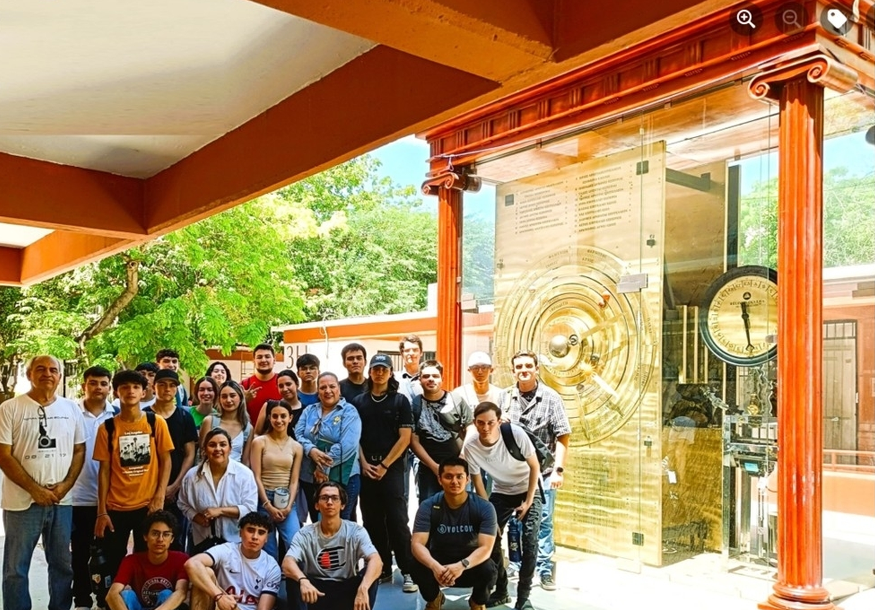
Figure 4 A huge Antikythera Mechanism working model, an astronomical clock 10-times larger, is an educational device and tourist attraction at the University of Sonora, Mexico
The Antikythera Mechanism inspires us to dream beyond the limits of our time, teaches us that knowledge and harmony guide both cosmos and culture, and connects us across millennia — from ancient Greece to modern Los Angeles. Like the Olympic flame, it is a symbol of passion, unity, and endurance; like the Mechanism, it is also a beacon of wisdom, innovation, and continuity. Together, they remind us that the Games are not only a celebration of sport, but of the timeless human quest to understand, to create, and to belong to something greater.

The Antikythera Mechanism in the LA28 Olympics
Including the Antikythera Mechanism in the LA28 Olympic opening ceremony could have several positive impacts for Los Angeles, both symbolic and practical:

Cultural Prestige
Reinforces LA’s image as a global crossroads of culture, history, and innovation.
Links the city’s modern creativity to the ancient roots of civilization and science.
Positions LA not only as the “entertainment capital” but also as a curator of world heritage.

Inspiration & Education
Inspires young people in Los Angeles and beyond to pursue STEM, arts, and philosophy.
Showcases LA’s role as a science and innovation hub (Caltech, UCLA, NASA JPL, SpaceX).
Promotes educational partnerships with museums, schools, and universities.
The Antikythera Mechanism inspires on many levels:
Wonder: It shows that over 2,000 years ago, humans had the vision and skill to model the cosmos with gears and mathematics.
Continuity: It reminds us that the Olympic Games were always linked to celestial cycles, uniting sport, time, and culture.
Creativity: Just as ancient engineers translated philosophy into technology, we can transform today’s ideas into tomorrow’s breakthroughs.
Youth: As Cicero said of Archimedes, seeing such genius pushes the young to dream higher.
Tthe Antikythera Mechanism is not only an object of wonder but also a teacher across time:
- It teaches us about the Cosmos, it Harmony, Cosmic Music — how ancient Greeks studied the Sun, Moon, planets, and eclipses.
- It teaches us about human ingenuity — showing that curiosity and reason can build bridges across millennia.
- It teaches us about culture — linking philosophy, sport, and science in the cycle of the Olympic Games.
- It teaches us about ourselves — reminding us that knowledge, when shared, becomes civilization and legacy.

Global Recognition
Sends a message that LA celebrates not only sport and entertainment but also human achievement across time.
Positions LA as a city that honors both diversity and shared global heritage.
Creates worldwide media attention, elevating LA’s reputation as a host city that thinks beyond spectacle.

Tourism and Legacy
Attracts interest in cultural tourism: museums, exhibitions, and educational programs tied to the Games.
Strengthens LA’s long-term legacy from the Olympics—not just athletic, but intellectual and cultural.
Could lead to partnerships with Greek institutions and other international cultural bodies.

Symbolism & Identity
The Antikythera Mechanism symbolizes human curiosity and ingenuity—values LA embodies.
Complements the Olympic flame: flame = passion, unity; mechanism = knowledge, innovation.
Leaves a lasting symbolic image of LA as the city that connects past, present, and future.

The Mechanism Inspires
- Inspires youth to dream beyond their time.
- Inspires innovation, showing that ancient genius still fuels modern creativity.
- Inspires unity, linking sport, science, and culture across civilizations.

The Mechanism Teaches
- Teaches us how the cosmos was measured through reason and harmony.
- Teaches us the roots of the Olympic Games in celestial cycles.
- Teaches us that knowledge endures — shaping the past, present, and future.

The Mechanism Connects
- Connects ancient Greece with modern Los Angeles.
- Connects philosophy, sport, and technology in one timeless story.
- Connects humanity across generations — a shared quest for meaning and achievement.
The Mechanism Inspires.
The Mechanism Teaches.
The Mechanism Connects.

Cultural aspects
In 2023, Hollywood released Indiana Jones and the Dial of Destiny, where the central artifact is directly based on the Antikythera Mechanism and linked to Archimedes. Millions of people worldwide were introduced to the idea of this mysterious ancient Greek “computer” through a blockbuster film.
This creates a unique opportunity for Los Angeles as the host of LA28:
- Hollywood already built the story: The Antikythera Mechanism is no longer obscure — it’s now part of global popular culture thanks to Indiana Jones.
- Connection to the Olympic Games: In reality, the Mechanism calculated celestial cycles and determined the timing of the ancient Olympic Games. Linking it to LA28 would beautifully unite fact, myth, and cinematic imagination.
- Perfect Los Angeles symbolism: LA is the capital of both Hollywood storytelling and scientific innovation. The Antikythera Mechanism embodies both — science wrapped in myth, precision wrapped in wonder.
- Youth Inspiration: Just as Cicero said Archimedes’ inventions could inspire youth, today Hollywood’s storytelling + Olympic ceremony can inspire a new generation.
- Global Visibility: By featuring the Mechanism, LA28 could create one of the most memorable Olympic images ever — bridging cinema, history, sport, harmony, simplicity and science.

The Antikythera Mechanism: A Pythagorean Invention
Rooted in Pythagorean philosophy, which taught that the cosmos is ordered by number and harmony.
The Mechanism embodies this worldview: a device where gears translate cosmic physics and mathematics into visible motion.
It is both scientific and spiritual: showing how humans can measure sacred time (the Olympic Games) through rational order.

American Philosophy Connection
American thought often blends practical innovation with lofty ideals — from the Founding Fathers’ Enlightenment values to modern pragmatism.
Like the Mechanism, American philosophy celebrates the union of reason, freedom, and imagination.
The Olympic Games in Los Angeles can highlight this shared heritage:
Ancient Greeks: mathematics, harmony, and philosophy of the cosmos.
America: innovation, democracy of ideas, and progress.
Together, they show the continuity of human aspiration across civilizations.

High Tech and Los Angeles
LA is a global hub of aerospace, tech, and entertainment technology (NASA JPL, SpaceX, Silicon Beach).
The Mechanism is the ancestor of all high technology: the first analog computer.
Presenting it at LA28 links:
Ancient High Tech → the Antikythera Mechanism.
Modern High Tech → LA’s role in space exploration, AI, biotech, and cinematic innovation.
This connection positions LA28 not just as a sporting event, but as a celebration of human technological creativity across 2,500 years.

Conclusion
Featuring the Antikythera Mechanism at the LA28 opening ceremony unites three powerful traditions: the Pythagorean vision of a cosmos ordered by mathematics, the American philosophical spirit of innovation and human progress, and the high-tech creativity of Los Angeles. This symbolic gesture will inspire a new generation by showing that the search for knowledge and harmony is timeless — from ancient Greece to modern America.

