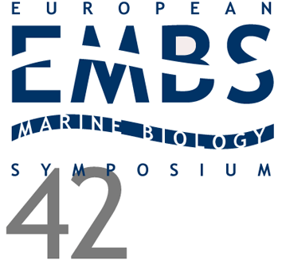 | 42nd European Marine Biology Symposium - Kiel, 2007

On the occurrence of the lessepsian emigrant Lagocephalus Suezensis in the Aegean Sea (Greece)

Megalofonou, P.¹ &�A. Spanou¹

¹Department of Biology, Section of Zoology-Marine Biology, University of Athens, Greece
Correspondence
Persefoni Megalofonou
E-mail: pmegalo@biol.uoa.gr
Abstract
Two specimens of the species Lagocephalus suezensis (Clark and Gohar, 1953) were captured by the net of a trawler near the island of Rhodes, along its northeast coasts. The first confirmed record of the species in the Mediterranean Sea was in 1975, in Lebanon. Since then there have been reports of its presence along the coasts of Israel, Turkey and Greece (island of Rhodes).
The identification of the two specimens was partly achieved through careful examination of their morphological features but mostly through several morphometric measurements and meristic counts. The comparison with similar measurements and counts from different specimens of the same species, which had been used in previous studies, confirmed the identity of the specimens in question. The recovery of the species near the island of Rhodes for second time during a short period indicates probably the occurrence of a settled population. Lagocephalus suezensis seems to be a dynamic lessepsian migrant that could invade rapidly all the eastern Mediterranean Basin.

