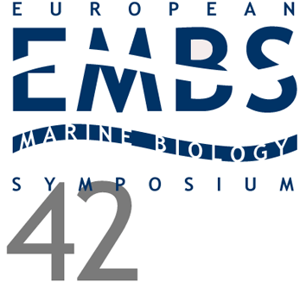 | 42nd European Marine Biology Symposium - Kiel, 2007

New records of the sharpnose seven-gill shark, Heptranchias perlo, in the eastern Mediterranean Sea (Aegean Sea, Greece)

Megalofonou, P.¹ &�G. Bardamaskos ¹

¹Department of Biology, University of Athens, Greece
Correspondence
Persefoni Megalofonou
E-mail: Email pmegalo@biol.uoa.gr
Abstract
A new record of the sharpnose seven-gill shark Heptranchias perlo (Selachii: Hexanchidae) in the eastern Mediterranean Sea is reported. This deep-water shark, which is relatively uncommon throughout its range in tropical and temperate waters, was taken incidentally on a commercial bottom-trawler in the Aegean Sea at a depth of 100 to 200 m. The specimens were 606-1060 mm in total length and 690-3705 g in total weight. Morphometric, meristic and biological characteristics have been recorded.

This study is co-funded by the European Social Fund and National Resources (EPEAEK II) PYTHAGORAS II.

