THE NATIONAL AND KAPODISTRIAN UNIVERSITY OF ATHENS
FACULTY OF ENGLISH LANGUAGE AND LITERATURE
MA PROGRAMME: “THE GREEK ELEMENT IN ANGLOPHONE LITERATURE”

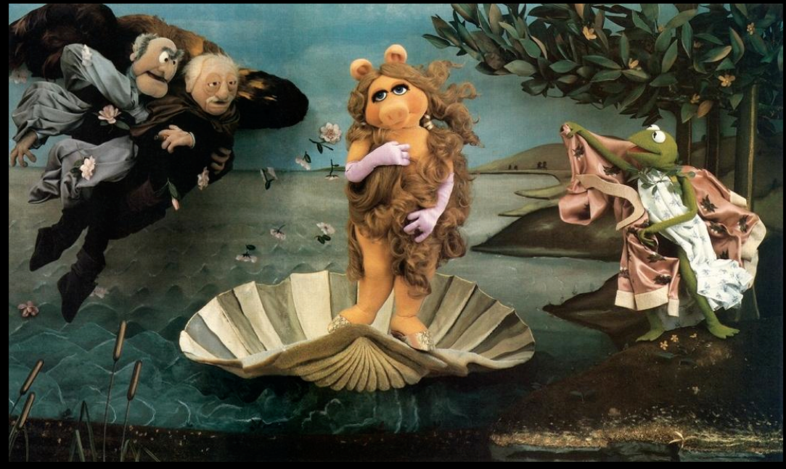
MINORITY MYTHUNDERSTOOD:
GREEK MYTH
IN AMERICAN LITERATURE

Dr. Christina Dokou--Fall 2019
Mondays, 12:00-15:00, Graduate Room (803)
Office Hours: Mondays-Wednesdays, 15:00-16:00, Office Complex 703

Course Description:
Through a combination of theoretical approaches including Comparativism, Mythanalysis and Cultural Studies, this course aims at exploring the relations between classical Greek myth and American literature. Specifically, as this field is rather huge, it shall focus on the examination of the ways in which contemporary U.S. minorities (racial, social, financial, gender or sexual) laid claim, in their literary production, to Greek myth as allegory or metaphor in order to express their identity and demand their rights, since the direct dominant discourse channels were forbidden to them. This relationship, however, between the bedding in the cradle of Western civilization and the stepchildren of that civilization’s latest and mightiest offspring, has not necessarily been smooth or unilateral: often this appropriation of myth, whose very recognizability has threatened to turn him into a cliché, implied a sort of—strategic, maybe—capitulation of the minority self to the valorized models of its own oppressors, while even more often yet mainstream voices would protest against the “sacrilegious” transformations of the mythological material in the hands of the minorities. The result is a field of literary expression both archetypal and agonistically fresh, in which students will be called upon to: a. learn to guide themselves with the help of mythanalytic theories, b. become familiar with a number of choice works of contemporary American literature that use re-workings of myth as their creative vehicle, c. learn to discern the various categories of literary myth use and evaluate their products.
Format and Evaluation:
The course consists of lectures by the instructor with the aid of A/V material, constructive class dialogue, and individual presentations of student work. Students will be evaluated on the basis of their participation in class (both orally and through small ad hoc written assignments), their presentation and their grade on a final individual research paper project. Students will be required to participate regularly in class discussions, which presupposes a systematic and careful pre-reading (or pre-viewing) of the material assigned for the date due, as well as of the classical myth on whose foundation the contemporary work is set.
Each student shall implement a 15-minute class presentation on assigned topics and will individually produce a final research paper (approx. 5000 words, not counting footnotes and bibliography), according to the guidelines put forth in the graduate Student Guide, on a topic of his/her own choice approved by the instructor (for suggestions, please see list below). The oral presentations, complete with visual aids, will be set as a mini-conference during the 12 session of our course. Each presenter shall be graded a. on the content and effectiveness of their presentation (given that the other qualities of your argument shall be graded with the final paper), b. on the mechanics of the presentation itself, and c. on the feedback and response to questions elicited. All work shall be submitted also in electronic form to the instructor on the date due. Student performance will be rated as follows:
- Final paper: 60% (thesis: 10%, outline: 5%; early bibliography: 5%; final draft: 40%)
- Presentation: 20%
- Participation: 20%

Note: Plagiarism in any of the written assignments in any form will result in an automatic fail for the entire course. In addition, failure to report to class within the first 10 minutes shall be marked as a half absence (for absences as ground for termination of student status, please consult the M.A. Student Guide). Should any other problems arise, please contact the instructor as soon as possible.

Texts:
A list of the works and theories to be analyzed, as well as pdf files for most of them, has already been uploaded on the instructor’s website at http://users.uoa.gr/~cdokou/. In addition, students need to provide themselves with copies of the films to watch, as well as the following books (any edition will do):
- Atwood, Margaret. The Penelopiad. 2005.
- Eugenides, Jeffrey. Middlesex. 2002.

Note: The films are to be viewed by you independently and before the relevant class session. Should you have any problems obtaining a copy, please contact the instructor for help.

References:
To cite myths professionally, you need access to respectable academic dictionaries, like the following:
- The Oxford Classical Dictionary, 4th ed., eds. Simon Hornblower, Antony Spawforth, and Esther Eidinow (standard reference tool for classicists).
- Cassell’s Dictionary of Classical Mythology, ed. Jenny March (available online free as pdf; contains source references for each entry)
- The Motif-Index of Folk Literature, ed. Stith Thompson. Every character, ritual and symbol worldwide explained.
- Perseus Digital Library at Tufts University. Online repository of the ENTIRE classical Greek and Roman corpus. Available at: http://www.perseus.tufts.edu/hopper/
- The Loeb Classical Library. Available at our Classics library, offers the ENTIRE classical Greek and Roman corpus with English-Original text side-to-side, edited, introduced and translated by eminent scholars.

Schedule:
WEEK I Introduction: The nature and uses of myth; comparative approaches to myth; myth theories
Readings: Lévi-Strauss (up until point 6.0); Raizis; Wilder, Proserpina and the Devil
Supplementary Readings (Optional help)
Eliot, T.S., “Ulysses, Order and Myth”
Holland, Norman, “Myth”
Karanikas, Alexander, “The Influence of Classical Greece on American Literature—An Overview”
___________________________________________________________________________________

WEEK II Mythanalytic Criticism—the Archetype
Readings: Jung; Freud; Frye, “The Archetypes of Literature (+ “Mythos Grid,” “Overview of Terms”); Raglan; Barth (Campbell explanation)
Watch: The Oedipus Wrecks segment by Woody Allen from the film New York Stories
Supplementary Readings
Eliade, Mircea, “The Problem” and “Survival of the Myth of the Eternal Return” chapters from Cosmos and History
___________________________________________________________________________________

WEEK III Liminal Heroism:
Readings: Eco; Middlesex (Book I-first 3 chapters of Book 3)
Supplementary Readings
Allen, Richard, “Hysteria and Heroism”

WEEK IV The American Minority Myth
Readings: Bakhtin; Middlesex (4th chapter of Book 3-end); THESIS DUE
Supplementary Readings
The MLA Newsletter, “President’s Column”

WEEK V Judaeo-Christian” VS “Classical” Trauma
Readings: Auerbach; Ozick, Edgar Lee Masters, “The City”
Supplementary Readings
Dokou, Christina, “The Pagan Condemnation and Orthodox Redemption…”
---. “America: No Second Troy”

WEEK VI Gendered Odd-ysseys
Readings: Penelopiad; Parker; Doolittle; Atwood
Supplementary Readings
Dokou, Christina, “Fruit of the Loom”
Rodriguez-Salas, Gerardo, “‘Close as a Kiss’: The Challenge of the Maids’ Gyn/affection”

WEEK VII Constancy and Change in Gaze Politics
Readings: “Cupid and Psyche”; Bottigheimer
Watch: When Night is Falling by Patricia Rosema; BIBLIOGRAPHY DUE
Supplementary Readings
Schor, Naomi, “Blindness as Metaphor”

WEEK VIII Three Re-versions of Philoctetes: A. Politics
Readings: Wilson; Mandel; Hadas
Supplementary Readings
Gerber, David, From Disabled Veterans in History
Greengard, Carola, From Theatre in Crisis
Poe, Joe Park. From Heroism and Divine Justice

WEEK IX B. Race
Readings: Walcott, excerpts from Omeros; OUTLINE DUE
Supplementary Readings
Figueroa, John, “Omeros”
Wilson, “The Wound and the Bow” essay from book of same title

WEEK X C. Sexuality
Readings: Jesurun
Supplementary Readings
Ντόκου, Χριστίνα, «Εξ’ οικείων τα βέλη»

WEEK XI The Classic and the Futuristic
Readings: Svich
Supplementary Readings
Schultz, William, “The Global Society Needs Myth”

WEEK XII: PAPER PRESENTATIONS

Suggested Texts for Final Paper:

Marion Zimmer Bradley, The Firebrand
Anne Carson, Autobiography of Red
Joel Coen, Oh Brother, Where Art Thou?
Charlotte Perkins Gilman, Herland
L. Ryder Haggard, She
Dean Hsieh, Athena (2-vol. manga)
John Barth, “Perseiad” and/or “Bellerophoniad” from Chimera
----. “Echo,” “Anonymiad,” and/or “Menelaiad” from Lost in the Funhouse
Zachary Mason, The Lost Books of the Odyssey
Madeline Miller, The Song of Achilles; Circe
Mark Merlis, An Arrow’s Flight
George Pérez (artist), Wonder Woman (at least vols. I-II)
Stephen Pressfield, Last of the Amazons
Philip Roth, The Breast, The Human Stain
Upton Sinclair, The Jungle
Steven Sherrill, The Minotaur Takes a Cigarette Break
Meredith Steinback: Tiresias, Or, The Birth of the World as We Know It
Donna Tartt, The Secret History
John Updike, The Centaur
Eudora Welty, The Golden Apples

