MINORITIES MYTHUNDERSTOOD
CLASS NOTES 2019-20

INTRODUCTION

Myth Definition
From Oxford Dictionaries online (http://www.oxforddictionaries.com/definition/english/myth)
  - a traditional story, especially one concerning the early history of a people or explaining a natural or social phenomenon, and typically involving supernatural beings or events:
"ancient Celtic myths"
synonyms: folk tale ·story ·folk story ·legend ·tale ·fable ·saga
allegory · parable · tradition · lore · folklore · mythos · mythus
  - a widely held but false belief or idea:
"the belief that evening primrose oil helps to cure eczema is a myth, according to dermatologists"
synonyms:·belief · old wives' tale · notion · legend · story

From The Free Dictionary by Farlex (the freedictionary.com/myth)
1. a. A traditional, typically ancient story dealing with supernatural beings, ancestors, or heroes that serves as a fundamental type in the worldview of a people, as by explaining aspects of the natural world or delineating the psychology, customs, or ideals of society: the myth of Eros and Psyche; a creation myth.
1.b. Such stories considered as a group: the realm of myth.
2. A popular belief or story that has become associated with a person, institution, or occurrence, especially one considered to illustrate a cultural ideal: a star whose fame turned her into a myth; the pioneer myth of suburbia.
3. A fiction or half-truth, especially one that forms part of an ideology.
4. A fictitious story, person, or thing: "German artillery superiority on the Western Front was a myth" (Leon Wolff).

American Heritage® Dictionary of the English Language, Fifth Edition. Copyright © 2011 by Houghton Mifflin Harcourt Publishing Company.

- Myth as: didactic (entertainment), aetiology, tradition, empowering-unifying identity
Bronislaw Malinowski’s “charter myth”
Émile Durkheim’s “collective [clan] consciousness to individual consciousness”
Jane Harrison’s institutionalization of religious ritual
- Myth as symbolic/literary enactment of “deeper” abstract truth
Sigmund Freud’s “Oedipus/Electra complex”
Carl Gustav Jung’s archetypes (in ritual and art)
Mircea Eliade’s “hierophany-eternal return”
Lord Raglan’s “the monomyth” (22 traits fit all)
Joseph Campbell’s “quest cycle”, the “Ur-myth”

Why is myth a particularly good vehicle for minority claims?
- Myth both celebrated repository of culture and “obsolete” carrier of falsities, itself elite and marginal
- Transformation, disguise, diversity motifs favor the underdog
- Authority not perfect in classical myths (gods anthropomorphic, heroes fall into hamartia)
- Can accommodate both status-supportive and subversive meanings
- Need for heroic self- and projected image
- “subaltern” discourse: a common, respected language for both minority and majority
- Past, tradition: non-threatening, status-bearing
- Relatable thanks to archetypal motifs, characters

THORNTON WILDER, “Proserpina and the Devil”
-Effect of rendering gods as Christian/secular puppets, handled by inept “manipulators”
a. continuity, universals of myth (e.g. the psychopomp Hermes/Michael)
b. parody, debunking of status and prestige of classical figures
-Re-definition of “passion play”: not religious martyrdom, but petty/vicious “passions” of manipulators, “passionate” self-destructive desires of nubile daughter
-Symbolic meaning of setting: upsetting of ethical expectations by equalizer death
-Renegotiation of the role of women vis-à-vis the original myth (Proserpina given agency, though still victimized by gendered norms, Demeter handicapped by gender and religious restrictions)
-The end as allegory: power of heaven/hell debunked, innocence as self-destructive, mother-daughter bond destroyed by social strictures
CONTINUED FROM LAST TIME:
- Myth as heuristic tool
Claude Lévi-Strauss’s primal formalism (“bundles” of mythemes” composed like language to offer “solution to a cultural contradiction”); what matters are patters of repetition in the structuring of mythemes, a “leitmotiv” that offers the deeper meaning of the story
T.S. Eliot’s “mythical method”
Northrop Frye’s “archetypes of literature”, mythopoetics, myth criticism
- Myth as a systemic mechanism
- Myth as versatile “truth”
(Jack Zipes)
Lévi-Strauss: “the mythical value of the myth remains preserved, even through the worst translation” (430).
- Myth myth-understood…(Gayatri Spivak’s “subaltern” discourse for minorities)
Myth today
- (Post)modern myth:  - comic-book heroes  - memes, urban legends,  - conspiracy theories,  - cyberpunk technology  - post-apocalyptic visions | 1.Old models still operant (e.g., Harry Potter)  2.“Traditional” myths revised (critique, parody, alternative p.o.v.)

Difference between myth and folktale: folktales are self-contained, autonomous, while myth is systemic, rhizomatic, cannot be understood unless viewed in its most extensive associations possible.

MYTHANALYTIC CRITICISM—THE ARCHETYPE

SIGMUND FREUD (1856-1939)
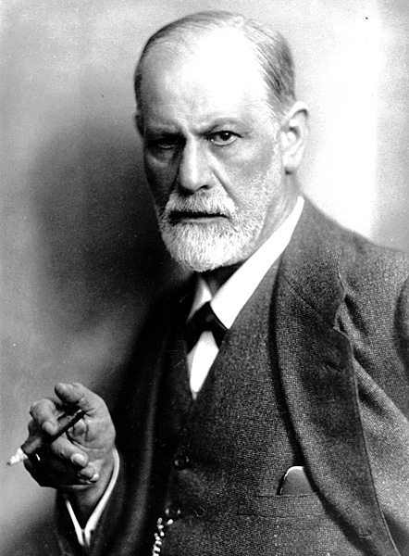
Structure of the mind—the unconscious
Psychoanalysis (“talking cure”) and resistance to interpretation
The Interpretation of Dreams (1900)
Totem and Taboo (1912)

Myth as a formulation of immanent & personal unconscious schemata (pleasure principle of the id: libido & death drive, repetition compulsion)

Cultural myth: 3 taboos from murder of Primeval Father as basis for civilization (=repression): murder, incest, cannibalism
Personal myth: The Oedipus complex during the phallic developmental stage (about 5 years)
Literature as
a. therapy (forepleasure and catharsis)
b. analysis material
c. map of human being through “universals” (in “bad” literature especially!), modified by “markers” (e.g., Hamlet)
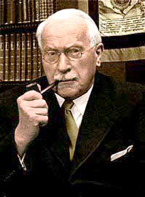
CARL GUSTAV JUNG (1875-1961)

“On the Relation of Analytical Psychology to Poetry” (1922)

Myth as one of the sites for the manifestation of schemata from our collective unconscious known as archetypes
Df: “a primordial image… be it a demon, a human being or a process that constantly recurs in the course of history, culture and civilization and appears wherever creative fantasy is freely expressed.”
Archetypal symbols (original subconscious language, nontranslatable yet immediately recognized) expressed in art by extraverted artist drawing from/being taken over by “autonomous creative complex” to heal cultural blanks

Four major archetypes
Self (Hero)
Shadow (Trickster, Adversary)
Animus (Father/God, Wise Old Man)
Anima (Mother/Earth Goddess, Triple Goddess, Terrible Mother)

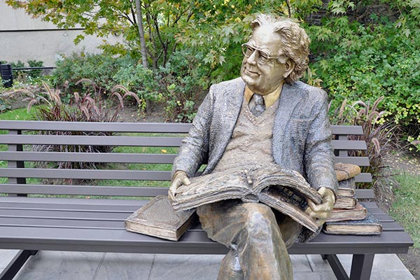
NORTHROP FRYE (1912-1991
Anatomy of Criticism (1957)
-Literature analyzed via a system of archetypes, primal patterns derived from myth, that form the “order of words”:
“Archetypes are associative clusters, and differ from signs in being complex variables. Within the complex is often a large number of specific learned associations which are communicable because a large number of people in a given culture happen to be familiar with them.”
-5 phases of literary development: mythromancehigh mimetic modelow mimetic modeirony
-Myth retelling a sign of “self-referentiality” of literature; masterworks “revert” to mythic phase, for strength and renewal (“rhythm” in narrative, and oracular “pattern” of meaning)
-All literature retells the “sun-hero quest”

Four categories (“mythoi”) of 12 traits in combinations of 3+3:
- Spring: comedy (anagnorisis; idyllic, self-contained)
- Summer: romance (agnon; idyllic, innocent)
- Autumn: tragedy (pathos; bleak, innocent)
- Winter: Irony and satire (sparagmos; bleak, self-contained)

Frye’s schema as Joseph Campbell’s heroic quest cycle motif:
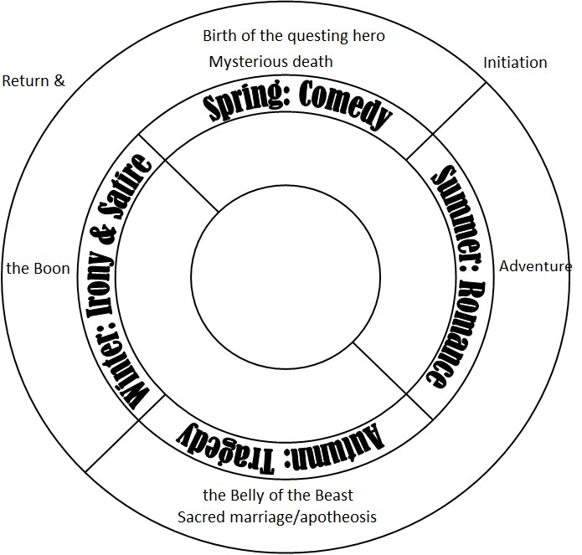

Woody Allen (1935- )
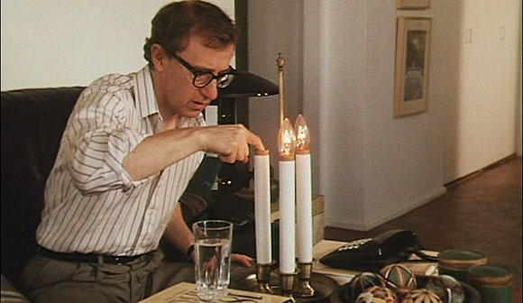
“Oedipus Wrecks” from New York Stories (1989)

- Genre classification
- Sheldon Mills as Oedipus or as Hamlet?
  - No origin (denies Jewishness, cuts off name)
  - Man of logic (lawyer, self-analytical, doesn’t believe in magic, only reason)
  - Finally defeated by the gods/his own unreasonable impulses
- “the Jewish mother” as archetype vs the “shiksa” first fiancé
- Where is the father?
- Symbols: Manhattan skyscrapers (camera p.o.v.)
The suicide mode
The responsive crowd of NYorkers
The mother sky image
The magician’s act (box and swords)
The psychic as successful mate
The “eye/I” of psychoanalysis
- Conclusion: resolution or resignation?
(esp re: Jewishness within goy tradition)
HEROISM

- Definition of a hero
  - Archaic
  - Classical
  - Tragic
  - Contemporary (anti-hero; superhero; virtual avatars and selfies)
- Lord Raglan: 22 traits of the monomyth
- Heroic cults
- Liminality and hubris
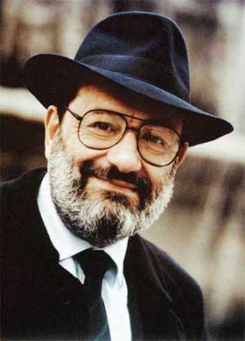
UMBERTO ECO (1932)
Semiotician, cultural critic (from middle ages to hyperreality), philosopher, author (The Name of the Rose)

“The Myth of Superman” (1972)
Superman
-created in 1936 NY by Jerry Siegel and Joe Schuster
-American cult Messiah idol world cliché
-Modern society (techno-carceral) demands super-heroes to compensate for increased stress-reducing fantasy needs
-Why super-man and not god?
-Difference between:
MYTHIC HERO | NOVEL HERO | SUPER HERO
Eternal, “fixed” | temporary | Time-bound stories but without aging
Predictable (pity and fear generated by plot twists, but end known) | Unpredictable  (plot as aesthetically-charged) | “new” stories but predictable scheme
Godlike | Human (universal) | Godlike, but with alter ego
Consumed by glory | Consumed by time | Unconsumable
Mythical time, closed and metaphorical | Realistic or manipulated time, but for didactic purposes | Closed causal chain of plot, kills causality time iterative scheme (endless, pointless reboot)
Beyond morality | Subject to morality | Moral
Stands for grand truths (archetype) | Stands for human condition (historic/ social type) | Stands for politics of apathy, confusion, non-responsibility “paternalistic” control
Universal | Civic | Status quo (property)

-Destruction of causality via: indeterminate time between “episodes,” alternate/imaginary times, “reboots,” “parsifalism”

COMICS/POP CULTURE HEROES OF ALTERNATIVE ITERABILITY?
-X-Men: allegory of actual events (Shoah, apartheid, AIDs epidemic)
-Xena: consumed

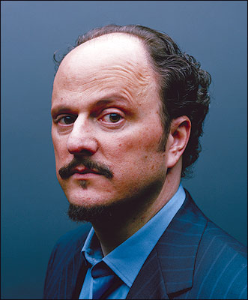
JEFFREY EUGENIDES (1960-)

Author of The Virgin Suicides, Middlesex (Pulitzer Prize 2003), The Marriage Plot, and short stories

-Middlesex plot elements
-an author and protagonist of Greek descend
-transgressive behavior
-queer bodies and sexualities as a metaphor for Greek minority ethnicity
-a quest for identity between the individual and the multi-collective, the fabulistic and the realistic, the exigencies of present and past.

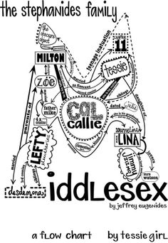

-Diaspora as a mythic Quest Cycle motif:
The Main Traits of Diaspora acc. to James Clifford, “Diasporas,” Cultural Anthropology 9.3 (1994)
-a history of dispersal,
-myths/memories of the homeland,
-alienation in the (bad?) host country,
-desire for eventual return,
-ongoing support of the homeland,
-a collective identity importantly defined by this relationship
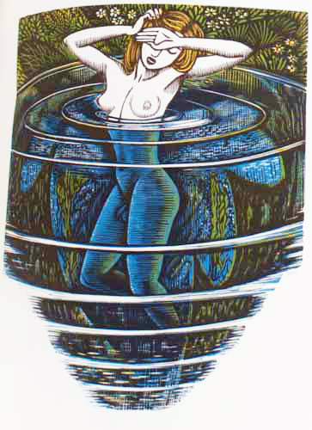
-mythological elements in Middlesex:
-“in medias res”, end known,
muse invocation
-the myth of Hermaphroditus
-the myth of Narcissus and Echo
-the myth of T(e)iresias
-the myth of the Minotaur
-the myth of the Olympians
-divination (silver spoon)
-metamorphosis (silkworm)
-the Melting Pot
-Hercules Hot Dogs
-the Nation of Islam Temple
-the Minotaur (birth-line maze)
-the myth of Utopia (USA)
what is “Middlesex”?

Woodcut: John Buckland Wright,
“Salmacis and Hermaphroditus, 1951”

MIKHAIL BAKHTIN (1895-1975)

“Epic and the Novel” from The Dialogic Imagination (1941; 1975)

EPIC | NOVEL
Complete, antiquated | developing
Elite (gods, heroes) | Carnivalesque (all people)
Voice of authority | Heteroglossia, polyglossia, popular laughter
Past-oriented (memory) | Bourgeois, present-oriented (knowledge)
Destiny | Growth, plot twists
“postmodern” (plays with other genres) | Harmonious (interacts decorously with o.g.)
Status quo | Parody
National tradition | individuality

What kind of a hero is Cal Stephanides in the Eco-Bakhtin schema?

ERICH AUERBACH (1892-1957)

New Criticism manifesto in Mimesis (1946): textual focus, but cultural extension in context
“Odysseus’ Scar” (chapter I of Mimesis)
-Homeric digression as ideology, not just artistic gesture
-Western civilization/literature’s representation of reality a Hegelian dialectic between
HOMERIC MODE | BIBLICAL MODE
Clear, detailed setting, thoughts, action | No details, obscurity, hints, abstraction
Eternal present (retardation) | Teleological divine drive above all else; suspense
Rational, composed logos | Elliptic speech, prophecies, mysterious plan of God
Lucidity, straightforwardness | Complexity, deep levels of God’s mind
Delight in human life | Awe in focus on God’s plan
Realistic, sweet fiction | Confusing meaningmidrashic interpretation needed for complex Truth (only 1 p.o.v)
Myth, legend | history
Charming, sublime | Mixed style (sublimitas et humilitas)
Elite | People focus (macrocosmic)
Stands by itself as fiction | Needs constant reinterpretation to fit new developments in human knowledge
Horizontal development (episode-rich) | Vertical development (all plot as God’s diachonic plan)
Beautiful lie, surface | Ugly truth, depth

CYNTHIA OZICK (1928- )
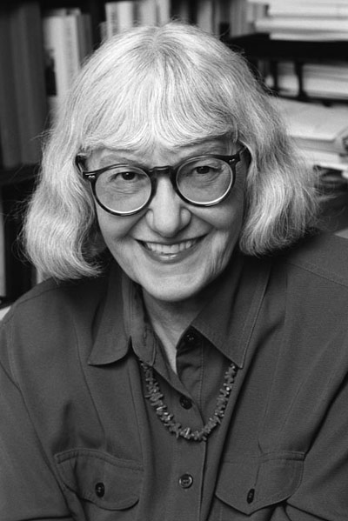
NY Jewish-American essayist, novelist, short-story writer

The Messiah of Stockholm (1987)
The Puttermesser Papers (1997)
The Pagan Rabbi and Other Stories (1971)
The Shawl (1989)
Fame & Folly: Essays (1996)

“The Pagan Rabbi”
-Desire for knowledge vs desire for life (books vs bodies)
-What kind of a hero is Isaac?
-Symbols:
Trilham’s Bay park (war monuments, fetid clam bay)
The highway construction
Narrator’s abandoned shiksha wife, fur business
Narrator’s father’s aphonia
Sheindel’s hair, asterisk scar
Isaac’s seven daughters and their fairy tales about inanimates having souls, emotions (Baruch Spinoza)
Potted plants at windowsill vs tree
The prayer shawl (tallit)
The (homo?)sexual encounter with Pan
The Dryad
The Law
-Meaning of ending: for Isaac; for narrator
-What is the role of the narrator?
-Parable of Jews in a gentile world
-Parable of Otherness in a heteronormative world

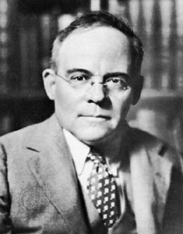
EDGAR LEE MASTERS (1868-1950)
Lawyer, poet, autor, essayist, playwright, biographer
Spoon River Anthology (1915)

“The City”
-Ballad rhythm and rhyme
-Diurnal course of Helios (why “like a red balloon”?)
-blend of ancient and modern (Achilles and Thersites; Wall Street; early delta vs later city)
-final image—why most terrible? (“crone”, “cloak”, “crucifix”)
-Was the replacement of Greek gods by Jehovah a good thing? How is Jehovah presented?
GENDERED ODD-YSSEYS

The mock-epic VS mocking the epic (ideological conventions)
“Mock-epic, also called mock-heroic, form of satire that adapts the elevated heroic style of the classical epic poem to a trivial subject. The tradition, which originated in classical times with an anonymous burlesque of Homer, the Batrachomyomachia (Battle of the Frogs and the Mice), was honed to a fine art in the late 17th- and early 18th-century Neoclassical period.” (britannica.com)

H.D. (1886-1961), “Helen”
-meaning of “still eyes in the white face”, “white hands”, “wan face” “cold feet”
VS “God’s daughter, born of love” (l. 13)
-why does Greece hate Helen?
-how is epic mentality questioned here?

Dorothy Parker (1893-1967), “Penelope”
-form of the poem: 5 male lines, 4 female, final line uncoupled
--how is The Odyssey questioned here?

Margaret Atwood (1939- )
“Siren Song”
-how does the siren’s perspective mock the epic?
Femininity as mysterious riddle, helpless, fatale

The Penelopiad
-a female epic or something else?
-Form: écriture feminine, herstory + burlesque, dirty para-Homeric tales + tragedy + postmodern insertions in contemporary tunes
-Dead p.o.v. (Hades an allegory; Lucian’s Dialogues of the Dead) VS “in medias res”—effect?
-does the final punishment bring any justice? Any respite?
-social commentary: P’s story of aristocratic daughter, wife and mother VS “Kiddie Mourn” and other chorus songs (class)
-gender trouble: marriage, in-law relations, suitors as war: a woman’s position
“the Battle of the Sexes” for 10 years
swan (Helen), wild duck (Penelope), geese (maids), owls (dead)
“An Anthropology Lecture” insertion: impact?
-Does P. blame herself? Should she?

CUPID AND PSYCHE

From: Lucius Apuleius, The Golden Ass (2nd century AD)
story of Hindo-European origin (Panchatantra), extant in Greece at least since 4th century BC
author an initiate to Dionysiac mysteries and cult of Asclepius, philosophy of Plato

Story elements:
Animal bridegroom motif (Beauty and the Beast)
Aphrodite Ourania / Pandemos
Psychological interpretation (love+soul=bliss, “love is blind,” “love hurts”)
Two kinds of love (instant lust, “in the dark” vs. constant, divine, proven love)
Psyche as philosopher (must see/know bridegroom, open box)
Seeing prohibition (common divine injunction) vs. Psyche’s active quest
- Orpheus and Euridice
- Actaeon and Artemis
- Lot’s Wife
- Narcisssus
- Psyche and Proserpina’s box
- Pandora’s box
- Medusa
- Garden of Eden
- Oedipus
- Teiresias
- Zeus and Semele
Image of Eros (c/c Plato’s Symposium): why a fearsome “serpent”?
Parable of family dynamics (sibling rivalry; mother-son bond; mother-in-law vs. bride)
The four tasks (grains; golden wool; fetching water; beauty secret)=?
Meaning of story re: role of woman

Bottingheimer’s point: different times/attitudes “date” myth from bawdy iconoclastic (re: gender) farce to courtly patriarchal romance
Capricious gods vs. rules of exogamous society
Psyche vs. Beauty (soul vs. looks)
Avoidance of vs. submission to the “beast”
Blindness and passion vs. sober acceptance, appreciation

PATRICIA ROZEMA
Award-winning Canadian film director; preoccupation with women’s issues, art-life relation
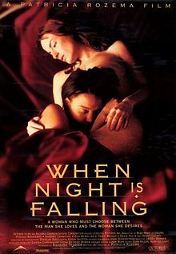
When Night Is Falling (1995)

Themes and myth motifs:
- Constancy and change (opening split scene)
- Forbidden love; Desire vs. rules
- Myth vs. religion
- The circus run by Timothy and Tory (locus amoenus) and the Christian college (Dionysian vs. Apollonian)
- Petra’s trailer
- Petra’s bow and arrow
- Picture on Camille’s desk
- Bob the dog
- Switched laundry; blouse with zipper
- Snow
- Paragliding
- The politics of vision

PHILOCTETES I: MINORITY POLITICIZED

The Philoctetes myth and its connections:
-Lemnos history
-The unhealable wound motif (Spear of Longinus)
-The Hieros Gamos/Divine Pair motif
-Sophocles’ innovations and personal/political investment
-the role of the archer in antique warfare

Edmund Wilson (1895-1972)
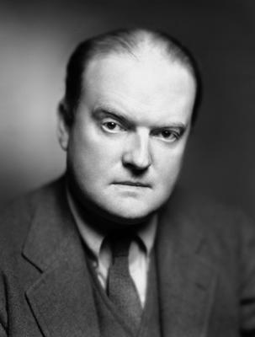
Author and literary critic, proponent of New Criticism and Marxism
“The Wound and the Bow” (1941)

-“The myth itself has not been one of those which have excited the modern imagination” (272).
-a psychological play without tragic ending or peripeteia
-relation of wound to bow: “superior strength as inseparable from disability” (287), psychological aberration as a source of offbeat “nobility”
-body VS nous: painful honesty VS political sophistry
-The personal as political: a projection of old Sophocles on Philoctetes (409BC) and Oedipus Coloneus (406BC) AND KING LEAR?, or/and Philoctetes as Alcibiades, the brilliant but side-shifting general
-personal grievance (Ph. and Neo) VS patriotic duty, kleos (Odysseus. Herakles)
-Neoptolemus leads Philoctetes to relent because he recognizes their common humanity in the abject invalid
-Prophesied relation of Neoptolemus+Achilles’ armor and Philoctetes+Herakles’ bow
=>Sophocles’ introduction of Neoptolemus to play AND DESERTED LEMNOS

Rachel Hadas (1948- )
Poet, critic, teacher and translator of modern Greek poetry

“Philoctetes”
-Why irony and hostility from a modern audience?
-“a god swung in on a high crane/ awkwardly booming” (ll. 7-8);
“the mumbling boy” (l. 9); “the old scene, Troy” (l. 11);
“turn your back…/ address” (ll. 25-26)
=> theatricality, artificiality?
-the question of the Greek language (VS American slurs)
-the role of nature (foot/root; wound as “rooted tentacle”)
-meaning of last line?
-Who/what is Philoctetes?
Marginal people
Old natural rhythms in a modern world
Myth as subaltern language/ unstable discourse (bow as language)
The professor herself, speaking to those who can’t understand

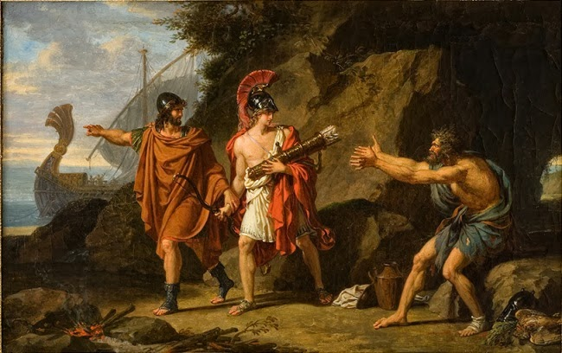
François-Xavier Fabre,
“Ulysses and Neoptolemus Taking Hercules’ Arrows from Philoctetes”

Oscar Mandel
Belgian-American poet, playwright, CalTech English Professor, translator and critic

The Summoning of Philoctetes from Philoctetes and the Fall of Troy (1961-81)

-Human being as “zoon politikon”—but at a price
-title addition=?
-The roles of Demodocus (name?) and Medon INSTEAD of Neoptolemus—why?
-Arrows+bow not given, but led by Gods to fashion in solitude (meaning?)
-Hercules’ appearance at start, not end: “master” chain of command, “war” as human existence, “beautiful and brutal”, manipulator of all virtues (family, poetry, friendship, love, patriotism) into traps
-First choral: brutality of war hideous to the simple, poor soldiers; yet brainwashed to “banality of evil”
-War as dirty rapine: “A man stops being a bandit only when he’s alone”
-Odysseus VS Philoctetes
-O: Paranoid fear of the Trojans getting hold of “the weapon” first=>?
-Ph’s first soliloquy: “no masters and servants here,” “I am now, good sir, become worthy of being a slave, having learned to work”
-Guest-friending the stranger (Ph) VS fearing, preying on the friend (O)
-O watching from afar VS Ph experiencing first-hand
-O commands, hides motives VS Ph asks, trusts, shares
-O universally admired, respected “almost a god” (why not just evil? Why soldiers thuggish + pitiful?) VS Ph. abject to nigh all
-Ph ironic VS Odysseus’ “doublespeak” and lies
-what does Philoctetes represent? Why is he hounded? Why does he break the bow (symbolic of?)?
-irony (?) of broken, humiliated Ph. hailed as “master”
-role of poet (with/out an audience), esp. in the end: “Now my peace begins. And to begin it, Demodocus must bury a man.” (Whom?)

PHILOCTETES—RACE
Derek Walcott (1930-)
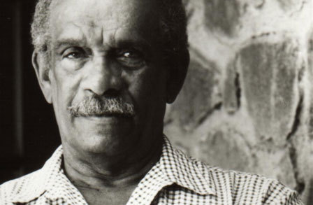
Afro-Caribbean poet (Nobel prize 1992) and playwright
Blend of Caribbean themes (slavery, poverty, multicultural identity) and European high canon in literature and art (studies)

Classics interest:
The Isle Is Full of Noises (1982)
Omeros (1990)
The Odyssey: A Stage Version (1993)

Omeros
-Considered as Walcott’s masterpiece
-Dantesque terza rima (ABA-BCB-CDC…) and heteroglottic different stories cut up and mixed
-Blend of The Iliad (Achille-Helen-Hector) and The Odyssey (Achille’s and narrator/Walcott’s vision quest for their true past; Major and Maud Plunkett) with St. Lucia everyday lives
-Philoctete:
Opening and closing story of Omeros
Meaning of wound (“moi blessé”)
Symbols: Philoctete’s narrative and wound-show
rusty anchor
Stinking flower
Line of ants
Sulphur cauldron bath
Ma Kilman’s name/bar VS legacy/ clothes during epiphany
Meaning of cure in relation to Ma Kilman (obeah woman/bar owner)
-The mixed ontology of the Caribbean person

PHILOCTETES—GENDER

-Use of Philo. as gay icon: Mark Merlis, An Arrow’s Flight; Adrienne Rich reference.
-“Queer” myth links to Philo. myth:
Unhealable wound: menstruation, AIDS, emasculation
The status of archers (Scythian archers in comedy)
Bow and arrow symbolism (Artemis)
Lemnos as Amazon island (Apollonius Rhodius, “stinking” Amazons)
Suffering as feminine loss of control
Relation to Herakles’ death/poison, Hera-Chryse

John Jesurun (1951- )
Playwright, director, multi-media artist; gay activism and postmodern techniques (e.g., serial play)
Occasional interest in “queering” legendary/mythical figures: Faust, Joan of Ark
Philoktetes (1994)

-Written for actor friend Ron Vawter, dying of AIDS
Praised for its focus on linguistic aesthetics; Peter Campbell’s Derridean “freeplay of language” as unhealable/infinitely deferred wound
-beginning: “Listen to me” from beyond the grave; mix of “true” and mythic story
Why does Philo insist that Philo “is dead” or other?
-the meaning of the island
-Philo’s metamorphoses: Goddess Cybele/Rhea
“Moonstruck” monologue
-Prayer: acceptance of all life, ecstasy of Job:
For there is beauty in the center of all ugliness.
Remember that I am in everything.
Even in the ugliest thing,
Which is what I made you,
And I made you to discover that. (Jesurun 75).
The Baghavad Gita (“Song of the Blessed One”) from the Indian epic The Mahabharata
Also: “The First Day” narrative (barren bird as symbol of?)
-Why does Philo beg to be killed, declare his self-loathing?
What was his transgression? (“Sweetness”)
- Odysseus’ ideology:
references to Iraq war (attitude twds war?)
+ conservative homophobia (the Bush years)
“afraid of losing”
Why does he bleed and wither in the end?
-Role of Neoptolemus (“such a fag”; “Does it have anything to do with love?” “Kiss me”)
-Ending: what is the door leading out to the light?
POST-MODERNIZING MYTH

Jean-François Lyotard, “Defining the Postmodern”
-implications for myth
-Mircea Eliade’s notion of “eternal return”

Caridad Svich (1963- )
Latina-New Yorker playwright, translator and editor
Themes on transculturality, myth “transposed”
Divine Fire: Eight Contemporary Plays Inspired by the Greeks. New York: Back Stage Books, 2005.

Iphigenia Crash Land Falls on the Neon Shell That Was Once Her Heart: A Rave Fable
-Elements of Iphigeneia in Aulis and the Atreidae myth
How is this configuration postmodern?
-Diversification:
Adolfo’s incestuous desire
Aulis as airplane hangar/maquiladora rave party
Achilles as “a transgendered glam-rock star, beautiful and damaged”(3)—why does he sing the chorals?
Orestes as a drug-addicted infant with an adult voice weaned in a Gucci shoebox
Virtual MC
Use of video screen
Violeta Imperial and the Fresa Girls
Obsession with clothes and makeup

--What is the meaning of the “rave fable”?
Ciudad Juárez (border/narco)violence, Mexican culture of machismo, history of juntas
Meaning of title
“postmodern condition”: angst, apocalyptic nihilism

